

UNIVERSITY INSTITUTE COMPUTING



Project Synopsis : Voice Based Email For Visually Impaired People.

**Submitted By** **Submitted to:**

Ajay Soni (17MCA8002) Faculty Name: Prof. Ramanjeet Singh

**INDEX**

|  |  |
| --- | --- |
| **S. No** | **Particulars** |
| **1** | Acknowledgement |
| **2** | Certificate |
| **3** | Project Objectives |
| **4** | Description of the project |
| **5** | Project Environment |
| **6** | Technology description |
| **7** | Team size &details |
| **8** | Structure of the project |
| **9** | Static design of the project |
| **10** | Data Flow diagrams |
| **11** | Bibliography |

**ACKNOWLEDGEMENT**

I am highly indebted to Chandigarh University for their guidance and constant supervision as well as for providing necessary information regarding the project and also for their support in completing the project. I would like to express my gratitude towards member of my team for their kind co-operation and encouragement which help me in completion of this project. I would like to express my special gratitude and thanks to my teachers for giving me such attention and time. My thanks and appreciation also goes to my colleague in developing the project and people who have willingly helped out with their ideas.

**CERTIFICATE**

This is to certify that the project entitled **“Voice Based Email System for Visually Impaired People”** submitted by “**Ajay Soni (17mca8002)”** in partial fulfilment of the requirement for the award of the degree Master of Computer Applications are bonfire record of the word carried out under our guidance and supervision at **University Institute of Computing of the Chandigarh University.**

**…………………………………………...**

University Inst. of Computing Chandigarh University

**PROJECT ENVIRONMENT**

**HARDWARE REQUIREMENT**

* PROCESSOR - INTEL(R)1.60GH
* MEMORY - 2.00GB RAM
* HARD DISK - 1GB

**SOFTWARE REQUIREMENT**

* INTERFACE - Python
* DATABASE - MySQL
* PLAT FORM - WINDOW 8 or later

**TECHNOLOGY AND PLATFORM**

Platform used in project is Python and it uses Pycharm as IDE.

Python is most innovative language in the current programming world. It has tons and tons of libraries and modules that could be used in the projects.

Python is such a language which is capable of solving any kind of problem in the world.

It is currently used in all the parts of innovation like web development, apps, softwares, artificial intelligence, data science, machine learning, security and what not.

It is even google’s favourite language to solve there very typical algorithms.

**SOURCE CODE**



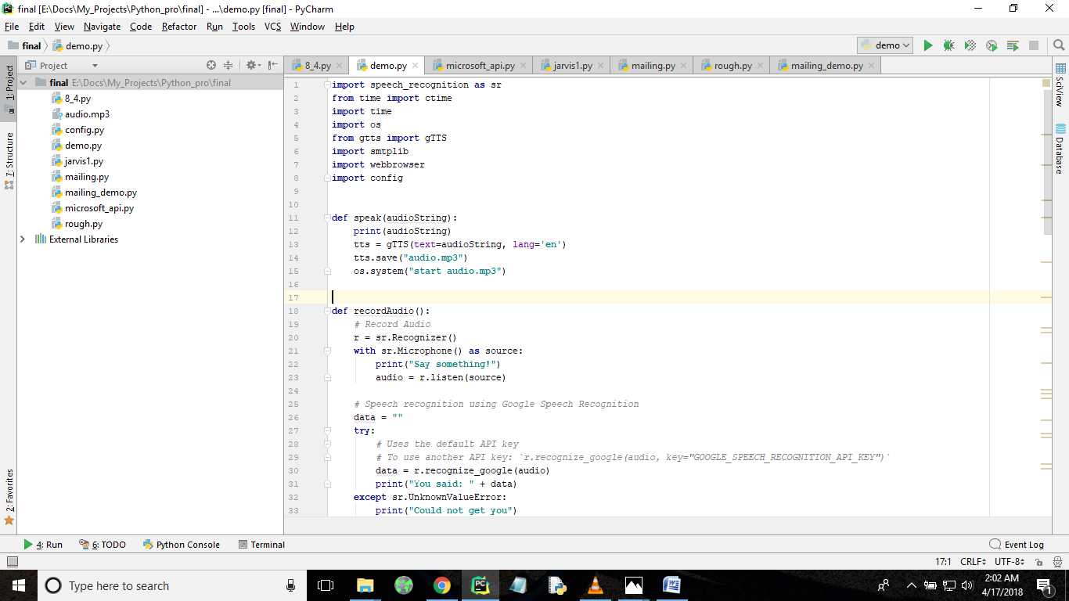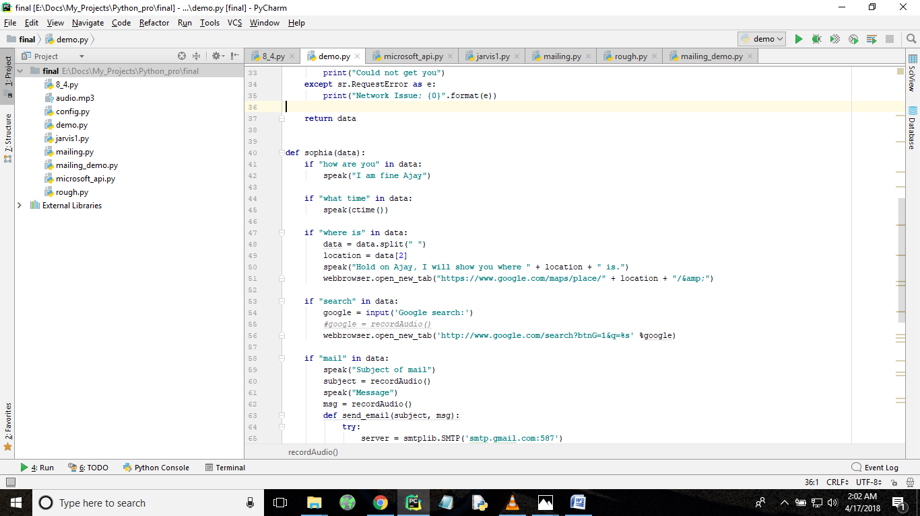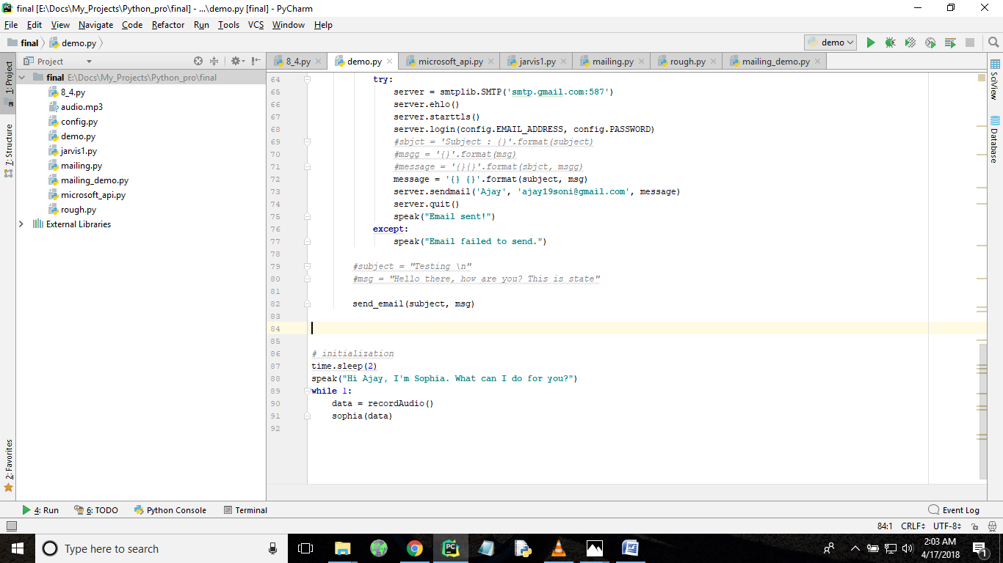

**WORKING PRINCIPLES**

* Microphones is the source which listens to the user
* Google API converts the voice instructions into string as well as audio format.
* Voice instructions are saved into audio format and played as a audio file.
* The same instructions are given as input to perform some tasks as shown below
* Basically, the moto of this project is controlling the emails by voice commands.
* When we command according to keywords we have defined in the program the mailing system will work over voice commands.
* It even does search web and say time over voice commands.
* In short it acts as an Virtual Assistant and we have named her as SOPHIA.

**FUNCTIONALITIES IN PROGRAM**

* **How are you** – It will reply as “I am fine Ajay”
* **What time** – It will speak the current system time

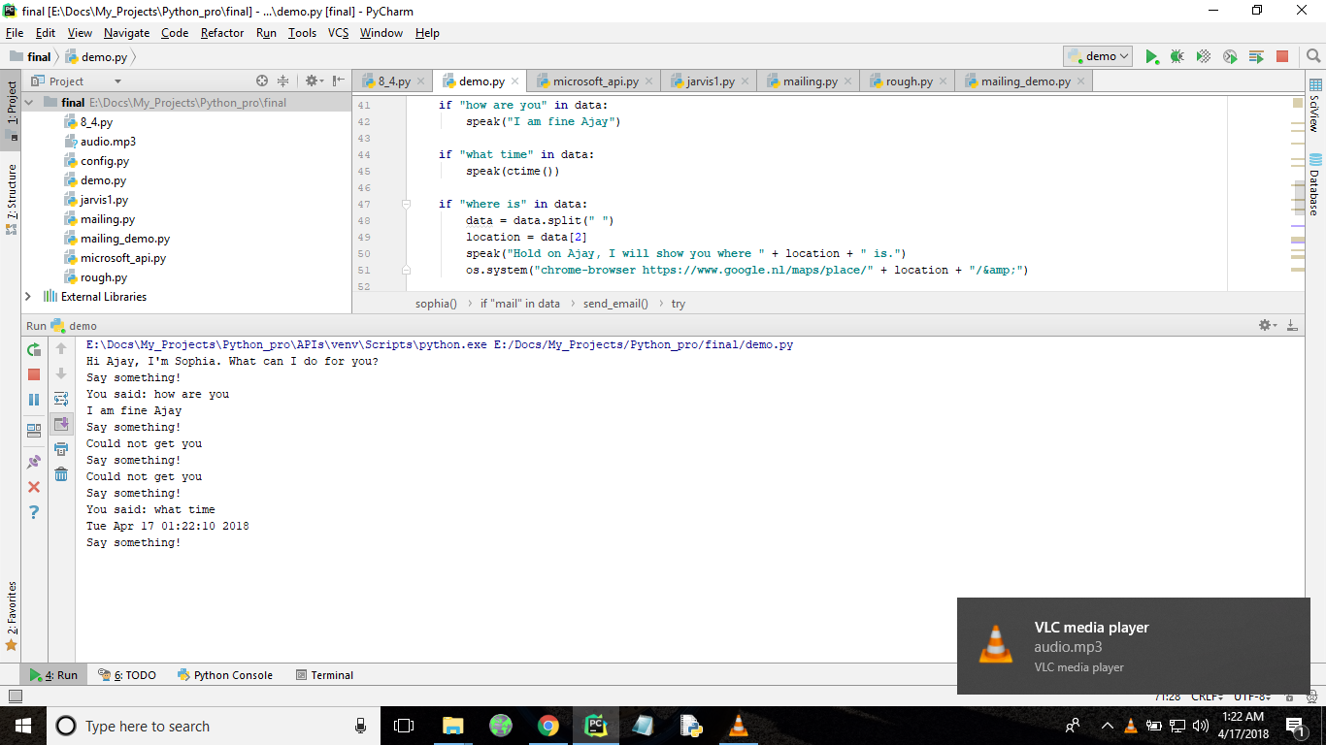

* **Where is (location)**– It will search for the location spoken as instruction in the web browser

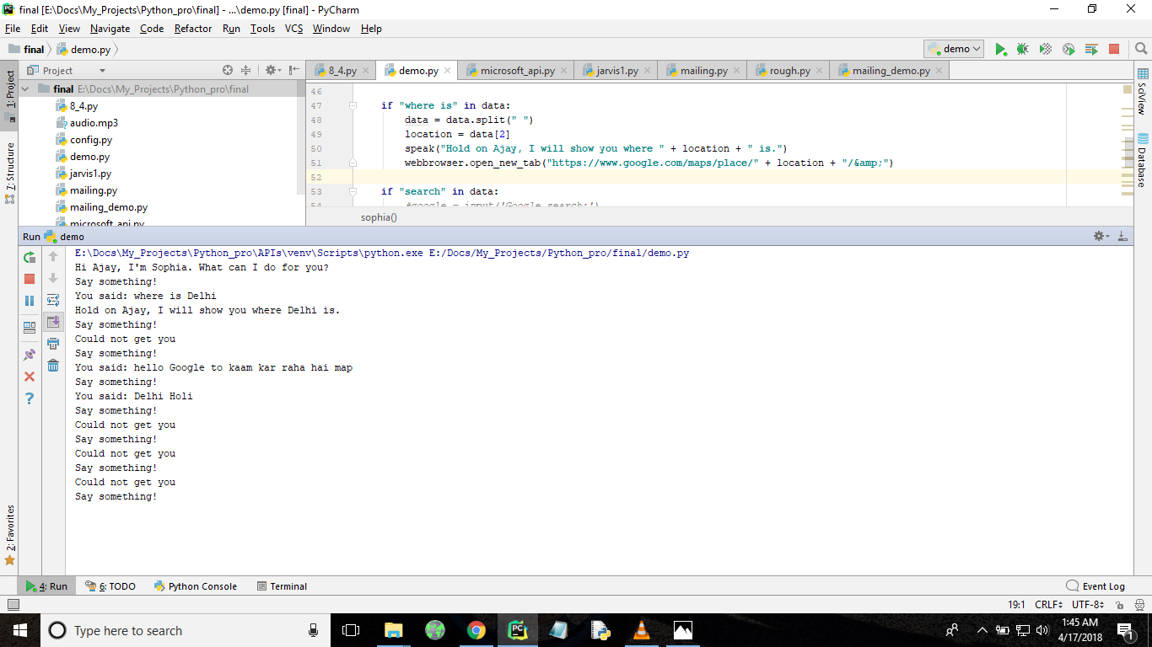

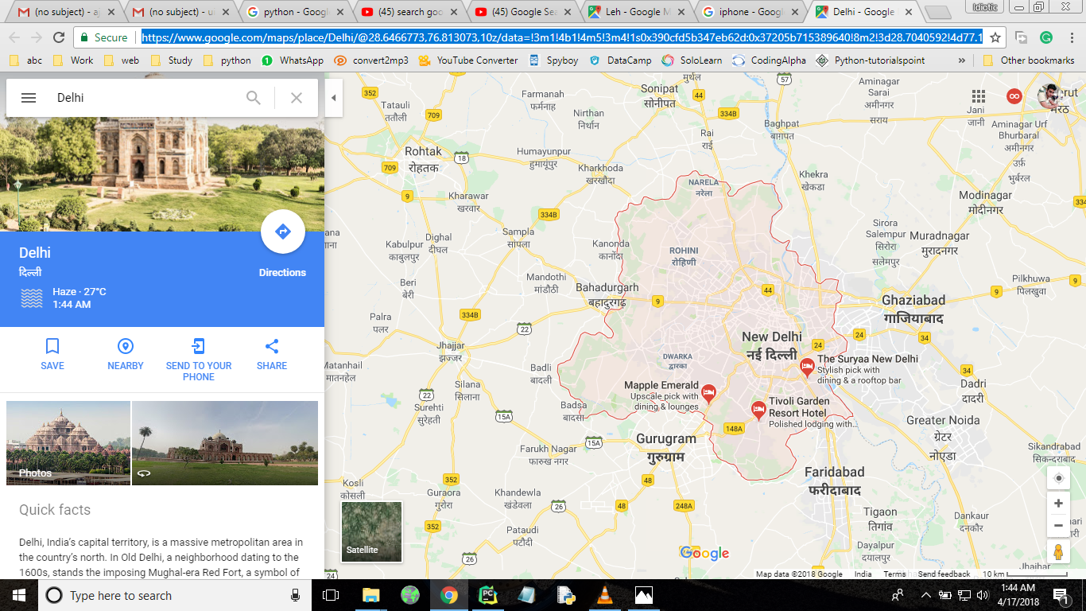

* **Search (keyword)** – It will search the String value provided as instruction in web browser

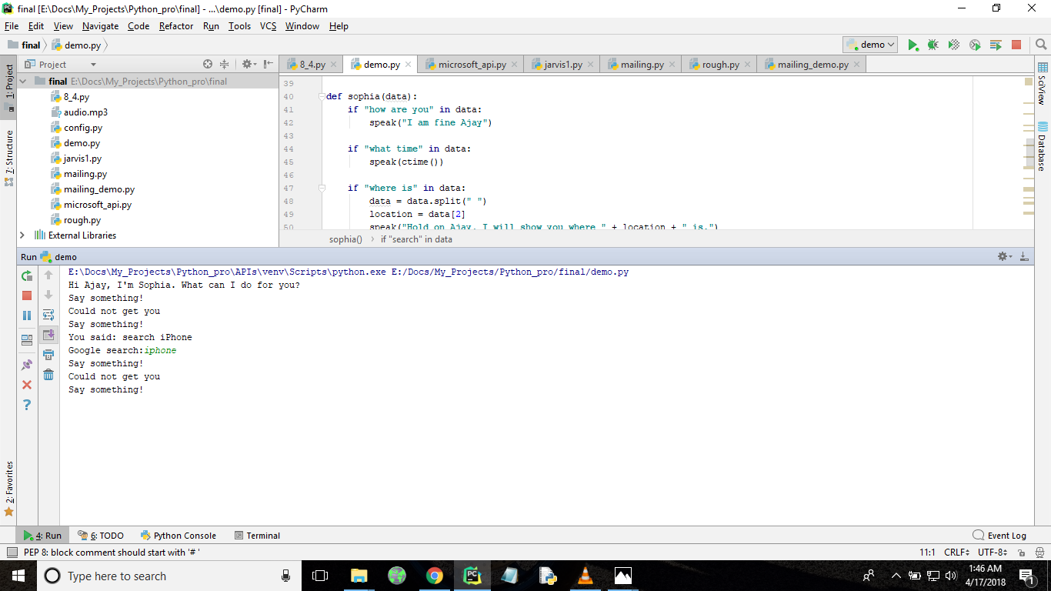

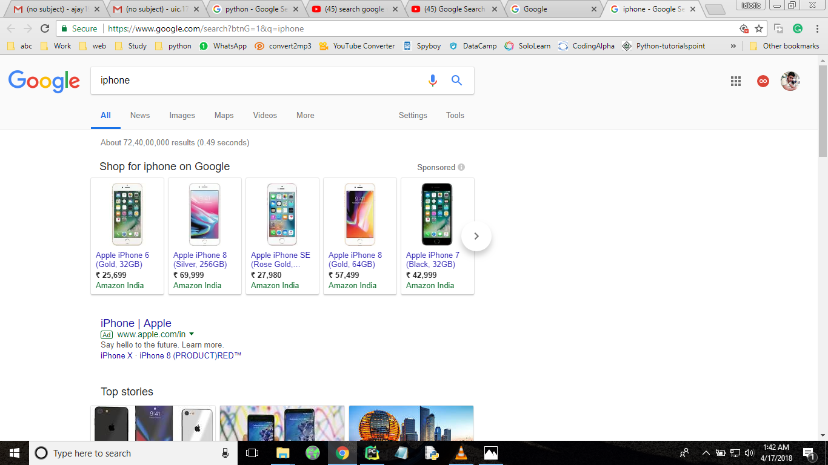

* **Mail** – It will ask for *“subject”* and *“message”* to be send and replies in *“Email sent”* if successfully done.

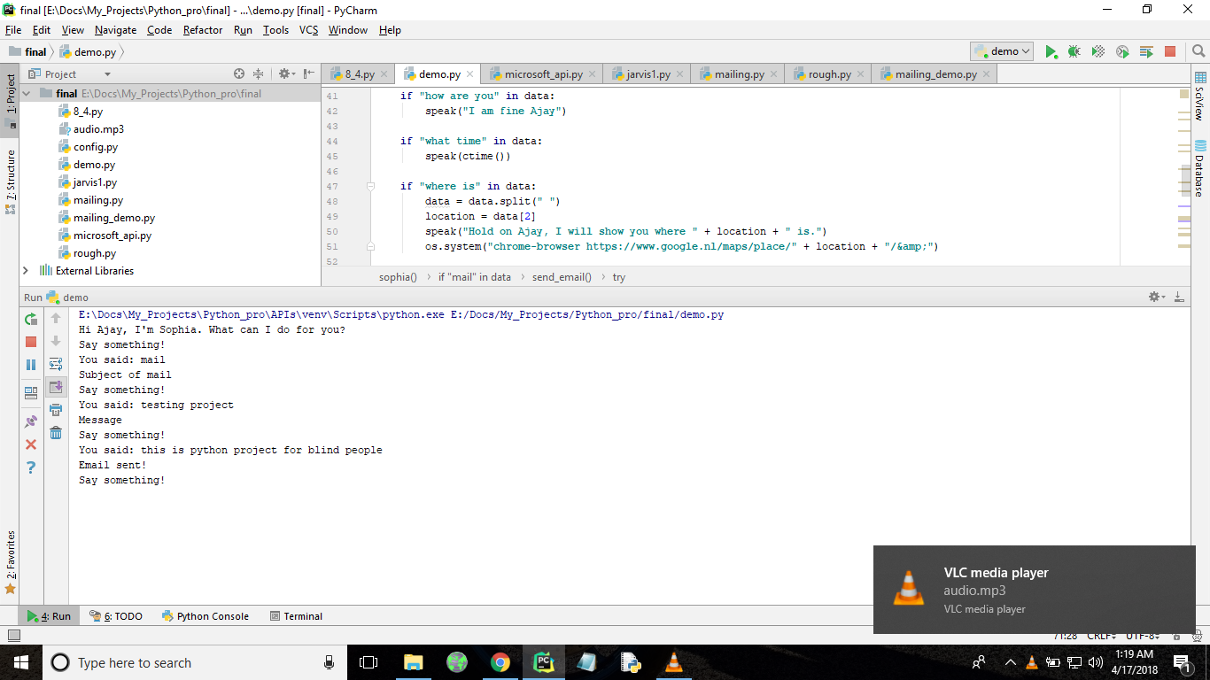

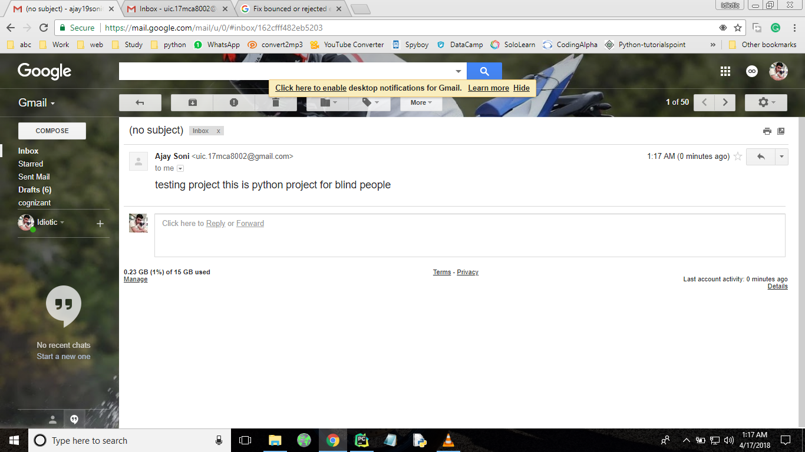

**DOWNSIDES**

* It’s a free API, so it is slow and it does need good internet connectivity.
* Error:

This error occurs when you cross your limit of sending mails as in this project free API’s are used and they have limit to the number of mails sent.

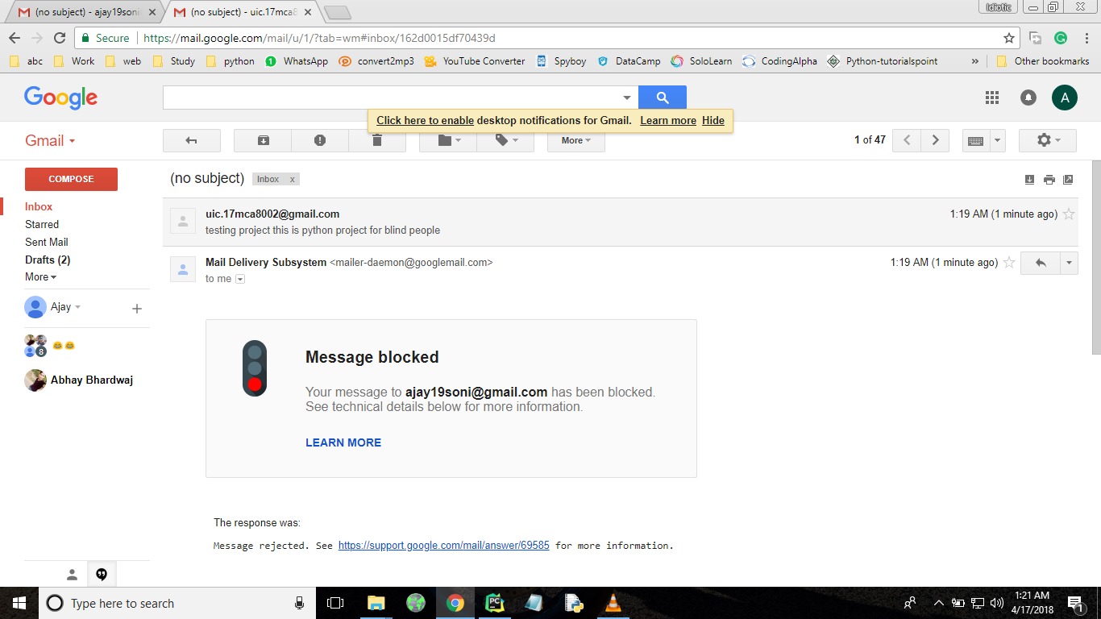

**BIBILOGRAPHY**

* [www.google.com](http://www.google.com)
* [www.python.org](http://www.python.org)
* <https://stackoverflow.com>